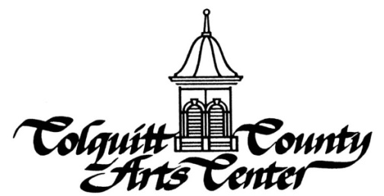
RENTAL CONTRACT

Name_____________________________________________________ Phone______________________

Address___________________________________________City_____________State__________Zip_____

Email Address____________________________________________________________________________

Rental Date________________________ Purpose_______________________________________________

Estimated # of Guests_________Event Start Time (doors unlocked)______Event End Time(doors locked)_______
(All events must end by 11 PM)
Set Up Date (if different than event date)_______________Set Up Start Time_______Set Up End Time________

Staff/Security Required for Rental:
____Staff Point Person $15 per hour for setup and run of event # hours _______ x $15 _______
____Additional Facilities Rental if over 10 hours ($50/hour over) # hours________x $50_______
____Security Officer Required if alcohol is served (1/100 guests) # hours _______ x $30 _______
____Auditorium Technician # hours _______ x $15 _______ (A) TOTAL STAFF FEES $__________

Facilities Needed for Rental (amount allows for 10 hour rental):
_____Ballroom/Solarium/Kitchen $650 _____Sculpture Garden $300
_____League Room $100 _____McCall Gallery $200
_____Media Room $100 _____Board Room $100
_____Kitchen $200 _____Dance Studio $100
_____Kaleidoscope Room $100 _____Stage/Auditorium (272) $100 per hour
_____Vereen Gallery (if available) $300 ($400 max daily)
_____Contemporary Gallery $100 (B) TOTAL FACILITIES RENTAL $________

Equipment Needs for Rental:
#_____ 25 Round Tables (seat 8) x $10 each =______ _____Upright Piano $100
#_____240 Chairs x $1 each = ______ _____Grand Piano $200
#_____ 22 Buffet Tables x $6 each = ______ _____Projector $75
#_____6 Bistro Tables x $5 each =______ _____Portable Bar $50
_____Sound/Mic $50
_____Portable Stage $100
(C)TOTAL EQUIPMENT RENTAL $________
Refundable Security Deposit (D) Security Deposit $200.00
TOTAL RENTAL FEES DUE (A-D) $___________

Less 20% Non-Refundable Deposit -___________

Balance Due by_______________________ $___________

______________________________________ _________________________________________
Signature of Renter Signature of Arts Center Representative
If tickets are sold for your event and you provide alcohol, you are responsible for the local and state license.
Ask about Linen/Dinnerware Rentals and Photo Booth Services available through separate contracts.

